PROJECT_TITLE

Introduction:
As we get older and our lives diverge into work, family and other responsibilities, its common to find it increasingly difficult to find overlapping free time to just sit and play games with your friends. This spans playing in person and online.

PROJECT_TITLE is an application designed to simply the process of scheduling time to sit back and play some games with your friends by providing an easy to use scheduling system.

PROJECT_TITLE allows for a user to sign up, add their multiplayer games, add their friends and schedule game sessions based on overlapping friend game libraries.
Friends can view each other’s game libraries in order to choose which games to play together.
Proposed schedules can be accepted, declined or have new times proposed by those invited to join, allowing for the organiser and participants to find overlapping time together.

This issue has been addressed in some ways by other applications such as Discord with its event system however it lacks the game library and ability for participants to propose alternative times.

PROJECT_TITLE is a people focused application with little value to the overall gaming industry and a primary focus on keeping close and distant friends together through games, even when life is busy.

User stories
Title | Description | Priority 1-5 | Notes
Scheduling | I want to be able to easily schedule days and times to play games with my friends | 1
Schedule focused interface | I want the apps main interface to be focused on the schedule so I can see my plans at a glance when opening the app | 1
Adding game library | I want to be able to put my multiplayer games into a library within the app. | 2
Scheduling specific games | I want to be able to add one or more games to the schedule to my friends know what I want to play | 2
Selecting friends | I want to be able to add and select friends from a list so there’s less typing and its faster to create the schedule | 2
Viewing friends libraries | I want to be able to view my friends games so that I know what games they have and what we can play together | 3
Schedule comments | I think it would be nice if each schedule had a comment section so we can provide extra details to our friends. For example why we want to propose a change to a schedule. | 5
Add other events to schedule | I want to be able to add other events to my schedule, that aren’t gaming sessions. For example the release date of a new game so I don’t forget. | 5

User flows
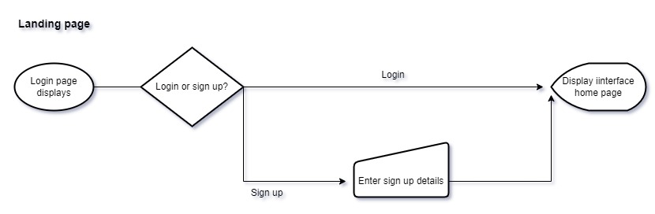
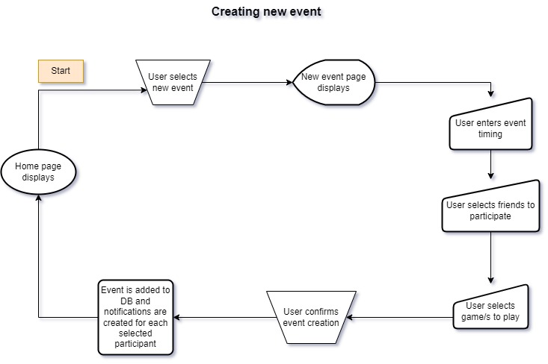
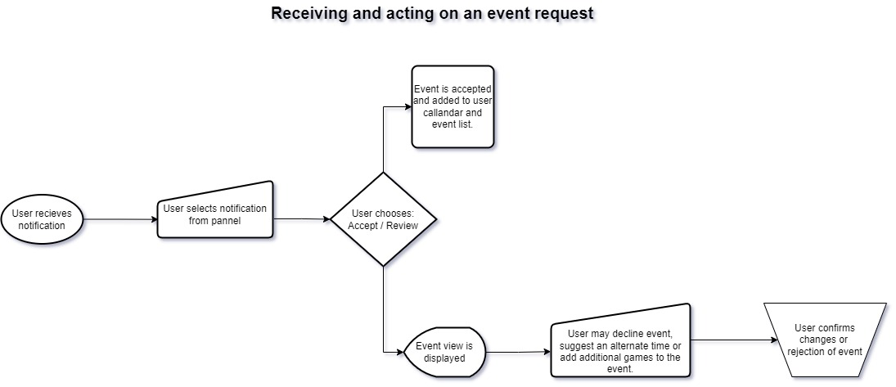

Wireframe Designs
Login:
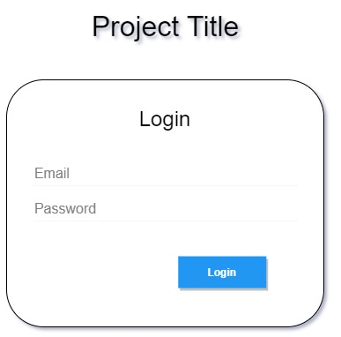
Sign up:
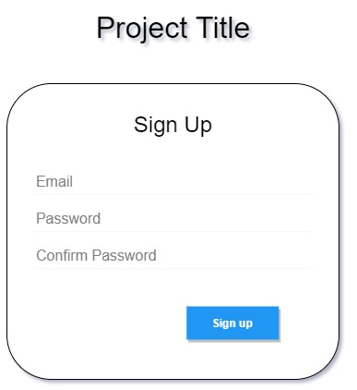
Home view:
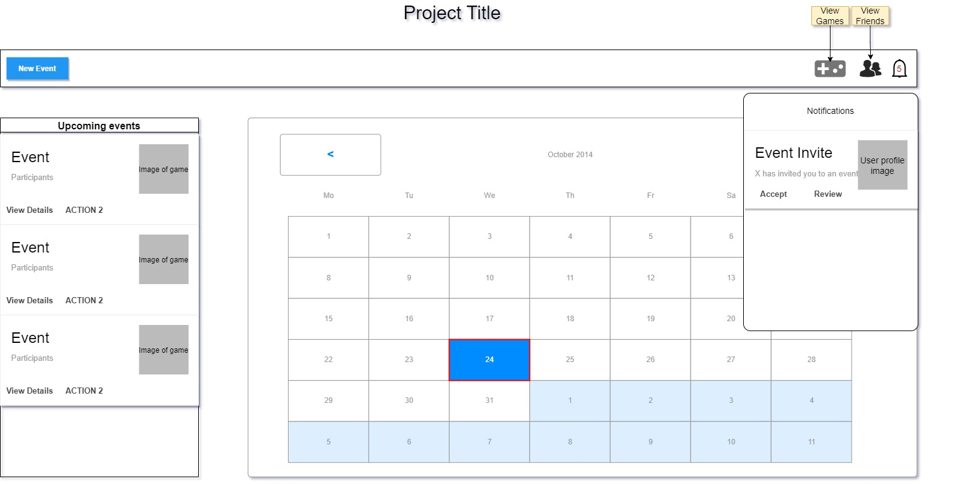
Create new event:
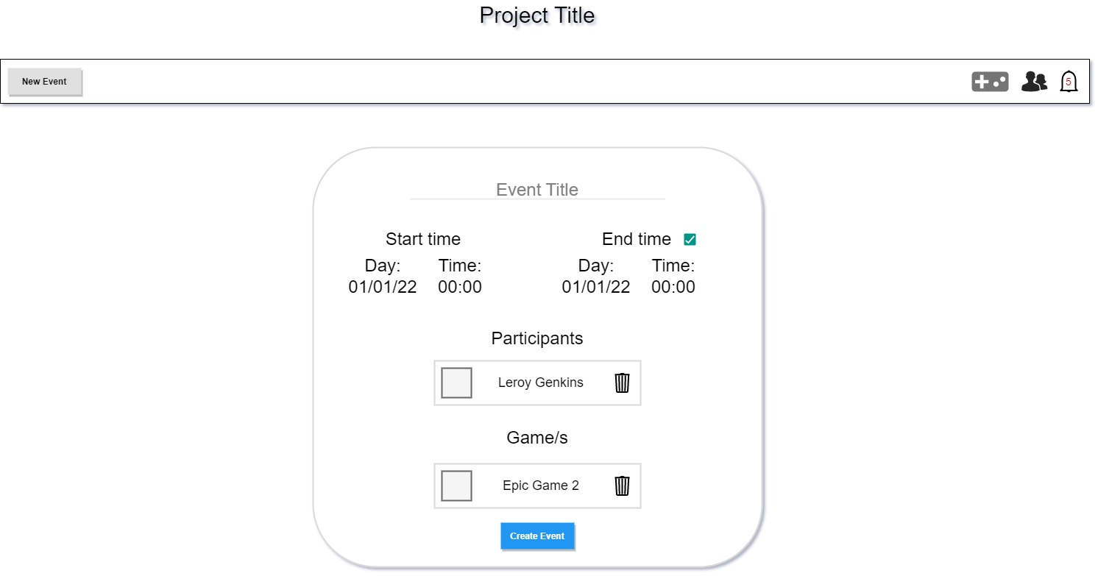
Event invitation details view:
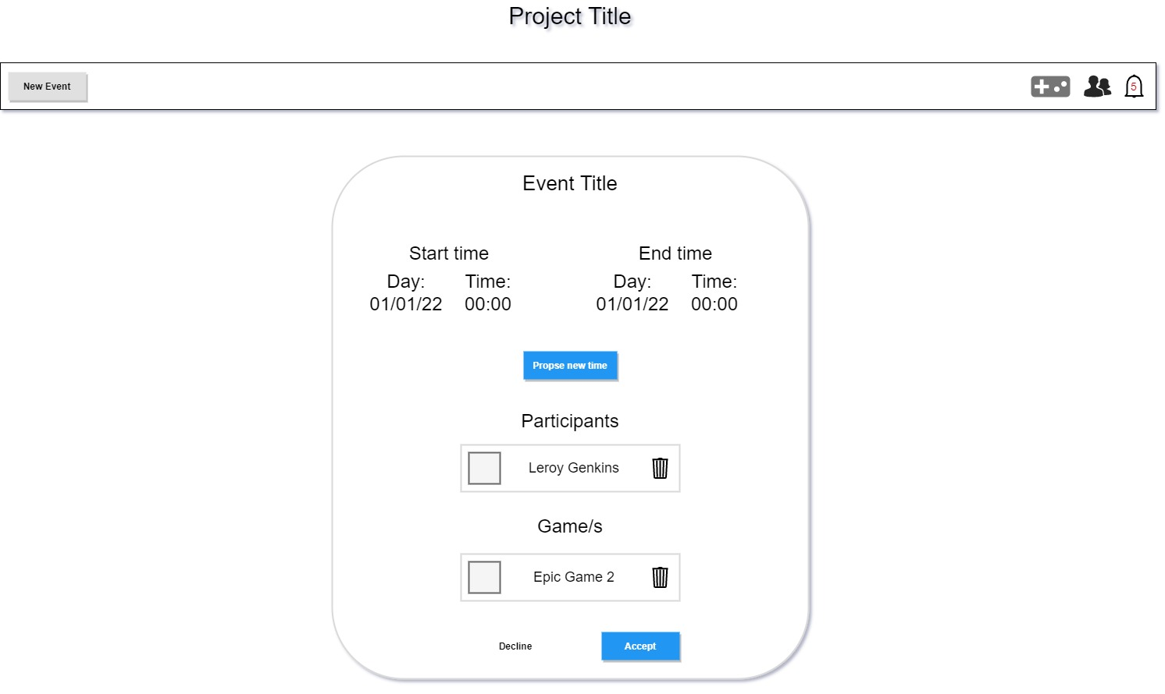

Scope
In Scope:
- Creating accounts
- Adding friends
- Adding games
- Creating events

Potentially out of scope:
- Notifications
- Schedule adjustment suggestions / voting on adjustments

Non-functional Requirements

- Passwords will be stored and transferred encrypted.
- Database credentials will be stored on the backend.
- Minimal personal details are stored. No personal details are required. People can use real or fake names at their discretion.
- The application will be designed to react quickly with the primary load times being from fetching existing or new events from the database on initial sign in.
- The application should have a 100% up time in ideal circumstances

